Music playlist & Listening-stats Manager

1.Abstract:
The Music Playlist and Stats Manager is a console-based software application developed in Java designed to streamline personal music organization and track user listening behavior. Traditional media management systems often rely on complex external databases and heavy architectural frameworks, which can introduce unnecessary configuration overhead for foundational learning environments. This project provides a lightweight, efficient, and completely in-memory solution that leverages core object-oriented programming paradigms and fundamental control structures.The system architecture is built around a dedicated Song class that encapsulates metadata attributes including title, artist, genre, and an active stream counter. Data persistence during runtime is managed using fixed-size arrays that maintain both the master song library and the user-defined custom playlist.

2.Project Objectives:
- Demonstrate Core Data Structures: Use a 1D array to store sequential song information and a 2D array to model matrix-based user listening statistics.
- Implement Console-Based User Interaction: Provide an interactive menu-driven CLI using a loop (while) and conditional branching (switch-case).
- Ensure Basic Input Validation: Handle invalid non-integer inputs gracefully via input checking methods (hasNextInt()) to keep the application running smoothly.
- Perform Array Traversal & Matrix Aggregation: Calculate combined statistics across 2D array rows and columns to identify top-performing tracks and display matrix data.
- Modular Code Architecture: Structure the program logic into clean, reusable methods for displaying menus, logging plays, rendering stats, and calculating metrics.

3.Advantages & Disadvantages:

Advantages:
💡 Academic & Conceptual Benefits
- Demonstrates Core Java Foundations
- Modular Code Structure
- Efficient Memory Usage
📊 Functional & Technical fits
- Multi-Dimensional Data Tracking
- Robust Input Validation
- Instant Analytics Engine
🌟 User Experience Benefits
- Clean Terminal UI
- Infinite Execution Flow

Disadvantages:
🛑 Technical & Data Limitations
- Static Storage Limits
- Temporary Data Retention
- Zero Input Flexibility
📉 Architecture & Maintenance Downsides
- Scalability Bottlenecks
- Lack of Data Encapsulation
- Basic Error Resetting: While the code stops invalid text inputs from crashing the program, it simply kicks the user back out to the main menu instead of prompting them to try entering their input again cleanly.

4.Implementation Details:
Programming Tool Used:
- Java Development Kit (JDK): Used for compiling and running the Java application code.
- Java Scanner CLI: Employs the java.util.Scanner utility to capture standard console keyboard inputs directly inside the command-line interface.
Java Concepts Used:
- Fixed-Size 1D and 2D Arrays: Utilizes a 1D array (String[]) to manage sequential song data and a 2D array (int[][]) to store a grid matrix of user-song tracking profiles.
- Control Flow Structures: Handles state switching using a flag-driven while loop alongside a switch-case selector to branch execution flow based on specific menu triggers.
- Input Validation & Exception Prevention: Utilizes token checks (hasNextInt()) to screen stream inputs before parsing, protecting the runtime pipeline against non-numeric mismatch exceptions.
- Matrix and Multi-Dimensional Traversal: Deploys single and nested for loops to parse row-by-column coordinates for grid printing and column-by-row tracking to sum individual tracking aggregates.
- Modular Method Architecture: Organizes application behavior into discrete, static sub-routines using strict parameterized signatures to pass reference memory data structures safely.
Main Modules:
- Menu Interface & Driver Engine: Drives the program execution via a continuous interactive command-line interface menu loop that processes, validates, and routes user requests.
- Playlist Viewer: Traverses and prints the fixed-size 1D playlist array to cleanly display all available songs along with their corresponding index identifiers.
- Activity Logger: Accepts explicit row (User ID) and column (Song ID) index coordinate pairs from the user, validates bounds constraints, and updates the matching grid element.
- Matrix Metrics Dashboard: Iterates systematically across the entire 2D matrix structure using nested loops to compile and render a grid layout of user-versus-song listening metrics.
- Analytical Aggregator: Performs a column-by-column cumulative summation across individual song records inside the 2D array to identify and flag the track with the highest user activity.
5.Java code:
import java.util.Scanner;

public class MusicPlayListManager {

public static void main(String[] args) {
try (Scanner scanner = new Scanner(System.in)) {

// Project Configuration Constants
final int MAX_SONGS = 5;
final int MAX_USERS = 3;

// 1D Array to store song titles
String[] playlist = new String[MAX_SONGS];
playlist[0] = "OMG Daddy(Thaman S,Western pop and funk-style choruses)";
playlist[1] = "Mental Madhilo(A.R. Rahman,Classical Carnatic fusion)";
playlist[2] = "Jala Jala patham(DSP,Romantic)";
playlist[3] = "Bum Ba Diga Diga(Anirudh Ravichander,Upbeat and energetic)";
playlist[4] = "PavazaMalli(Sai Abhyankar,Melodic and soulful)";

// 2D Array to store listening stats: Rows = Users, Columns = Song Play Counts
int[][] listeningStats = new int[MAX_USERS][MAX_SONGS];

// Variables and Data Types
int choice;
boolean running = true;

System.out.println("=== Welcome to the Music Playlist & Listening Stats Manager ===");

// Main Program Loop
while (running) {
displayMenu();
System.out.print("Enter your choice (1-5): ");

// Conditional statement to validate integer input
if (scanner.hasNextInt()) {
choice = scanner.nextInt();
} else {
System.out.println("Invalid input! Please enter a number.");
scanner.next(); // Clear invalid input
continue;
}

// Switch Case for Menu Selection
switch (choice) {
case 1:
displayPlaylist(playlist);
break;
case 2:
logSongPlay(scanner, playlist, listeningStats, MAX_USERS, MAX_SONGS);
break;
case 3:
displayStats(playlist, listeningStats, MAX_USERS, MAX_SONGS);
break;
case 4:
displayTopSong(playlist, listeningStats, MAX_USERS, MAX_SONGS);
break;
case 5:
// Operator utilization and exit flag update
running = false;
System.out.println("Exiting the application. Thank you for using the Manager!");
break;
default:
System.out.println("Invalid option! Please select a valid menu number.");
}
}
}
}

// Method 1: Display the current menu options
public static void displayMenu() {
System.out.println("\n--- MAIN MENU ---");
System.out.println("1. View Playlist");
System.out.println("2. Log a Song Play");
System.out.println("3. View Listening Stats Matrix");
System.out.println("4. View Top Played Song");
System.out.println("5. Exit");
}

// Method 2: Display the 1D Array contents (Playlist)
public static void displayPlaylist(String[] playlist) {
System.out.println("\n--- CURRENT PLAYLIST ---");
// Loop to traverse 1D array
for (int i = 0; i < playlist.length; i++) {
System.out.println("ID " + i + ": " + playlist[i]);
}
}

// Method 3: Log a play count into the 2D Array using Operators & Conditional Statements
public static void logSongPlay(Scanner sc, String[] playlist, int[][] stats, int maxUsers, int maxSongs) {
System.out.print("Enter User ID (0 to " + (maxUsers - 1) + "): ");
int userId = sc.nextInt();

System.out.print("Enter Song ID (0 to " + (maxSongs - 1) + "): ");
int songId = sc.nextInt();

// Conditional statement for bounds checking
if (userId >= 0 && userId < maxUsers && songId >= 0 && songId < maxSongs) {
// Arithmetic assignment operator to update listening counts
stats[userId][songId] += 1;
System.out.println("Successfully logged 1 play for '" + playlist[songId] + "' by User " + userId);
} else {
System.out.println("Error: Invalid User ID or Song ID selection!");
}
}

// Method 4: Display the 2D Array data (Grid matrix representation)
public static void displayStats(String[] playlist, int[][] stats, int maxUsers, int maxSongs) {
System.out.println("\n--- LISTENING STATS MATRIX (Users vs Songs) ---");

// Print header row
System.out.print("User ID\t\t");
for (int i = 0; i < maxSongs; i++) {
System.out.print("[" + playlist[i] + "]\t");
}
System.out.println();

// Nested Loops to traverse the 2D Array
for (int i = 0; i < maxUsers; i++) {
System.out.print("User " + i + "\t\t");
for (int j = 0; j < maxSongs; j++) {
System.out.print(stats[i][j] + "\t\t");
}
System.out.println();
}
}

// Method 5: Calculate aggregated statistics from the 2D Array
public static void displayTopSong(String[] playlist, int[][] stats, int maxUsers, int maxSongs) {
int maxPlays = -1;
int topSongIndex = 0;

// Outer loop column-by-column to total up the stats for each specific song
for (int col = 0; col < maxSongs; col++) {
int currentSongTotal = 0;
for (int row = 0; row < maxUsers; row++) {
currentSongTotal += stats[row][col]; // Using arithmetic operators
}

// Conditional block to identify the highest play count
if (currentSongTotal > maxPlays) {
maxPlays = currentSongTotal;
topSongIndex = col;
}
}

System.out.println("\n--- TOP PLAYED SONG ---");
if (maxPlays > 0) {
System.out.println("The most played track is '" + playlist[topSongIndex] + "' with an overall total of " + maxPlays + " plays!");
} else {
System.out.println("No play history logged yet. Try logging a song play first!");
}
}
}

6.Output:
cas1,case2,case3,case4,case5
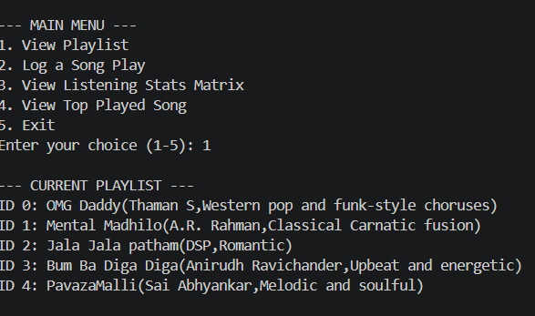
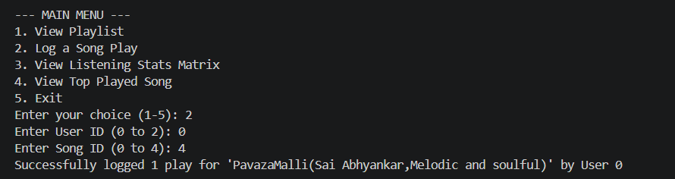
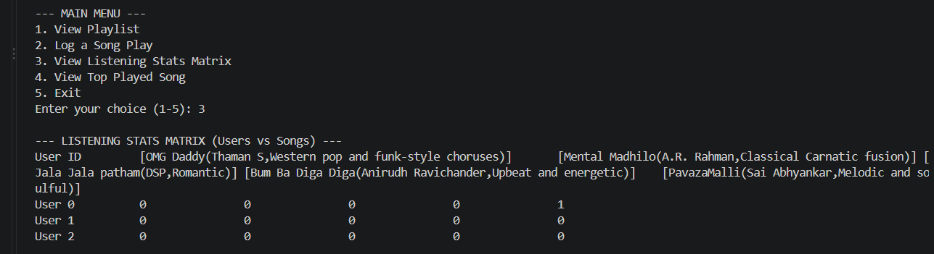
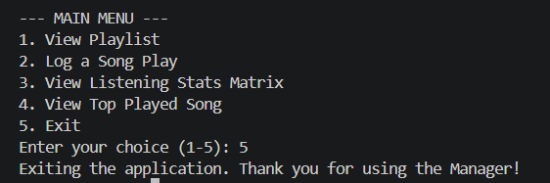
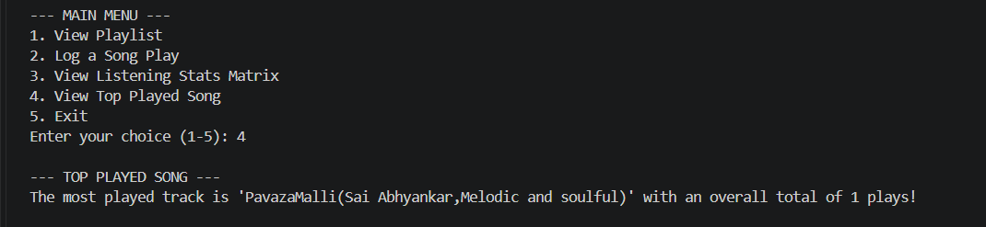
7.Conclusion:

The Music Playlist & Listening Stats Manager successfully achieves its goal as a foundational Java application by bridging essential programming concepts with a real-world multi-user scenario. By leveraging 1D and 2D arrays, the program creates a functional data matrix that maps individual user behaviors directly to a specific tracklist.
While the application provides an excellent showcase of core logic, modular methods, and terminal stability, it remains constrained by the inherent limitations of static structures, such as fixed array dimensions and volatile runtime data loss.
Ultimately, this project serves as a vital stepping stone in software development. It highlights how basic building blocks like loops and conditional branches form the backbone of analytical logic, while cleanly setting up the architecture for future object-oriented upgrades, file persistence, or dynamic data collections.

8.Future Work:
- Data Persistence: Save and load playlist data using external storage like JSON files, CSV, or a database (SQLite / PostgreSQL) to retain state across restarts.
- Dynamic Collections: Upgrade fixed-length arrays to dynamic collections such as ArrayList or HashMap to enable runtime modifications (adding/removing songs and users).
- Object-Oriented Design: Refactor plain text arrays into dedicated classes (Song, User, PlayLog) to cleanly encapsulate metadata like artist, genre, and timestamps.
- Robust Input Validation: Introduce centralized input parsing using try-catch blocks to prevent program crashes from unexpected user inputs.
- Advanced Analytics: Add genre/artist aggregations and basic recommendation algorithms (like collaborative filtering) based on user listening history.
- UI & API Integration: Transition the text console into a REST ful API using Spring Boot or build a graphical interface using React or JavaFX.

